**­**

|  |  |
| --- | --- |
| **Total Marks:** | **4** |
| **Obtained Marks:** |  |

**Web Technologies**

**Assignment # 03**

**Submitted To: Sir Zubair Ahmed**

**_______________________________________________________________________________________________________________________________________________________________________________________________________________________________________**

**Student Name: Ubaid Bin Waris**

**_______________________________________________________________________________________________________________________________________________________________________________________________________________________________________**

**Reg Number: 2212416 _______________________________________________________________________________________________________________________________________________________________________________________________________________________________________**

**Deployment on Ubuntu AWS**

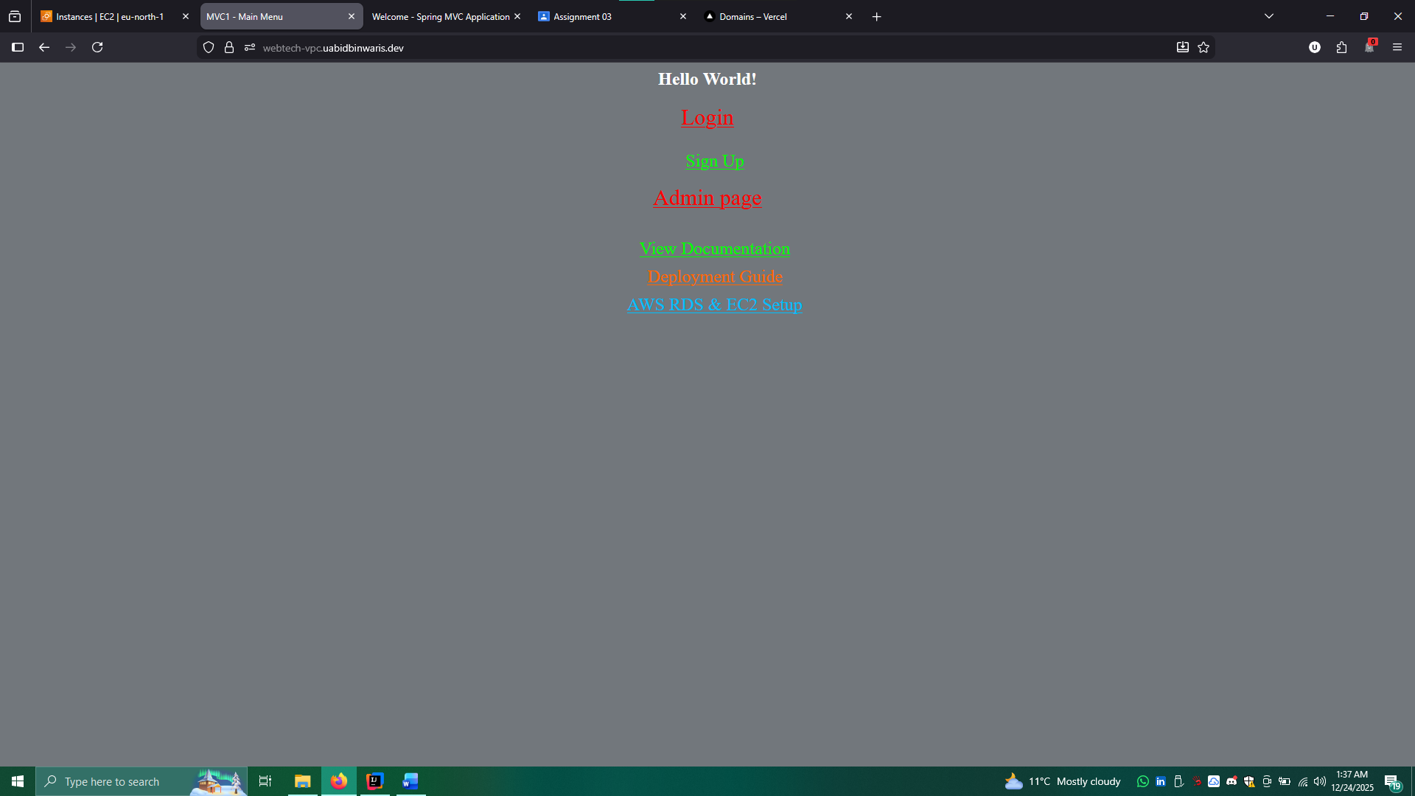

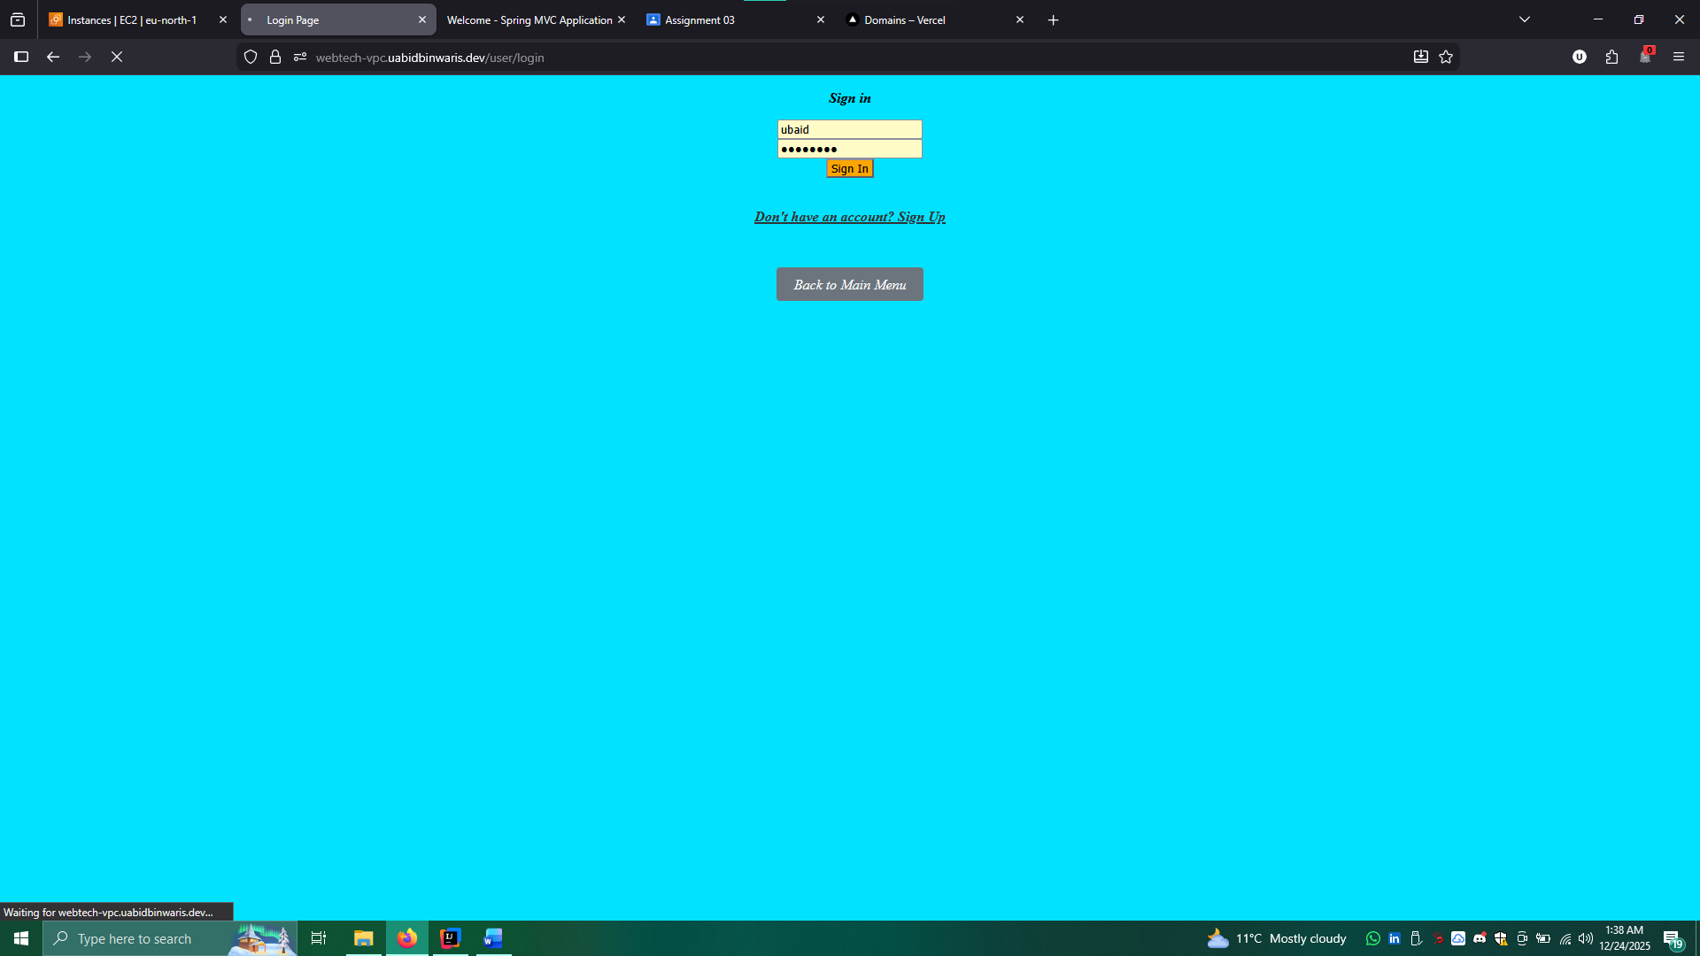

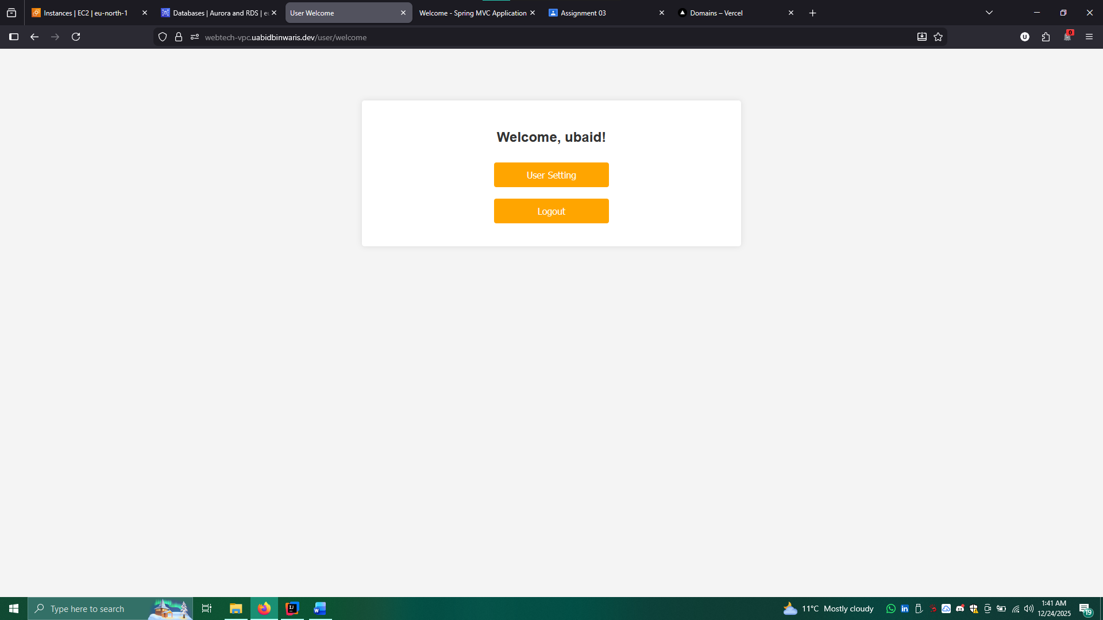

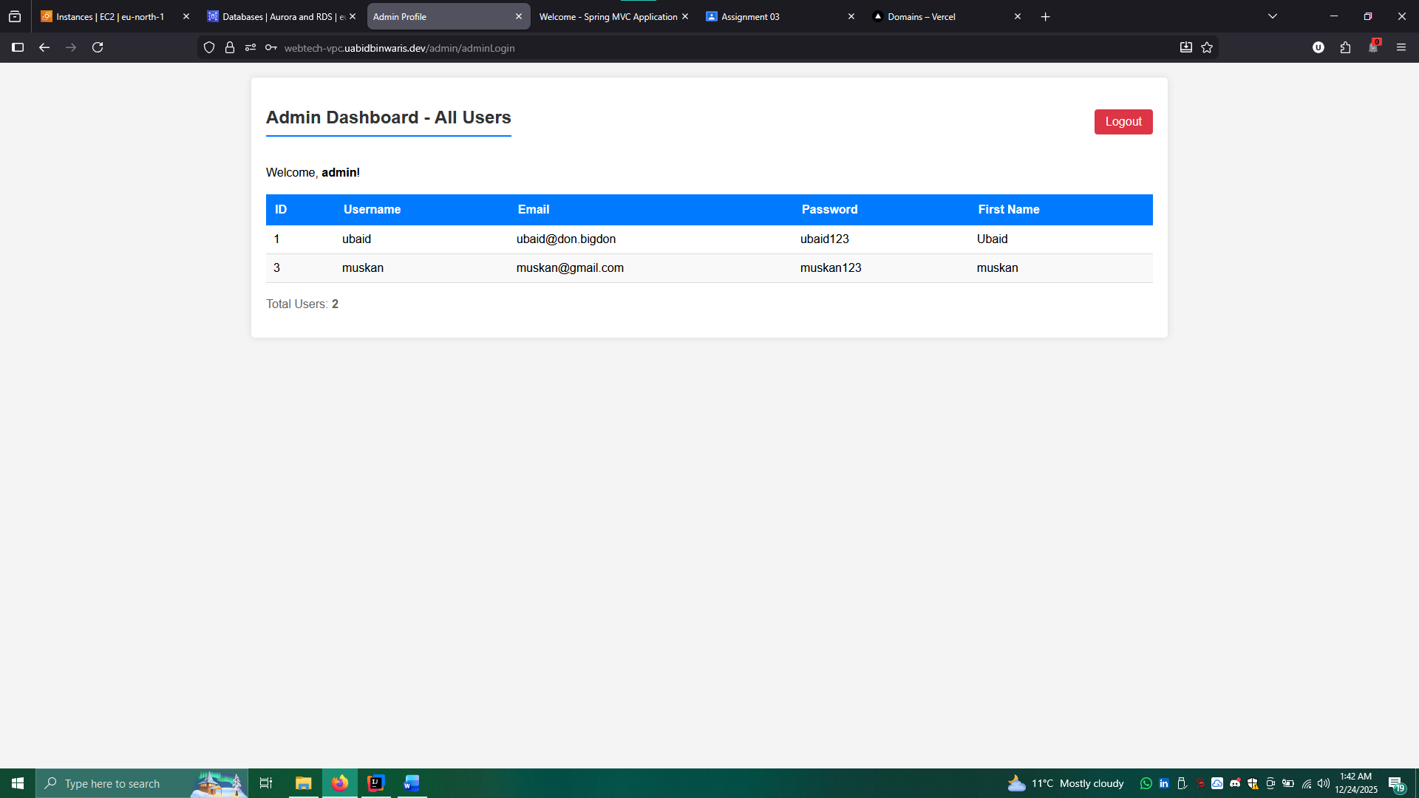

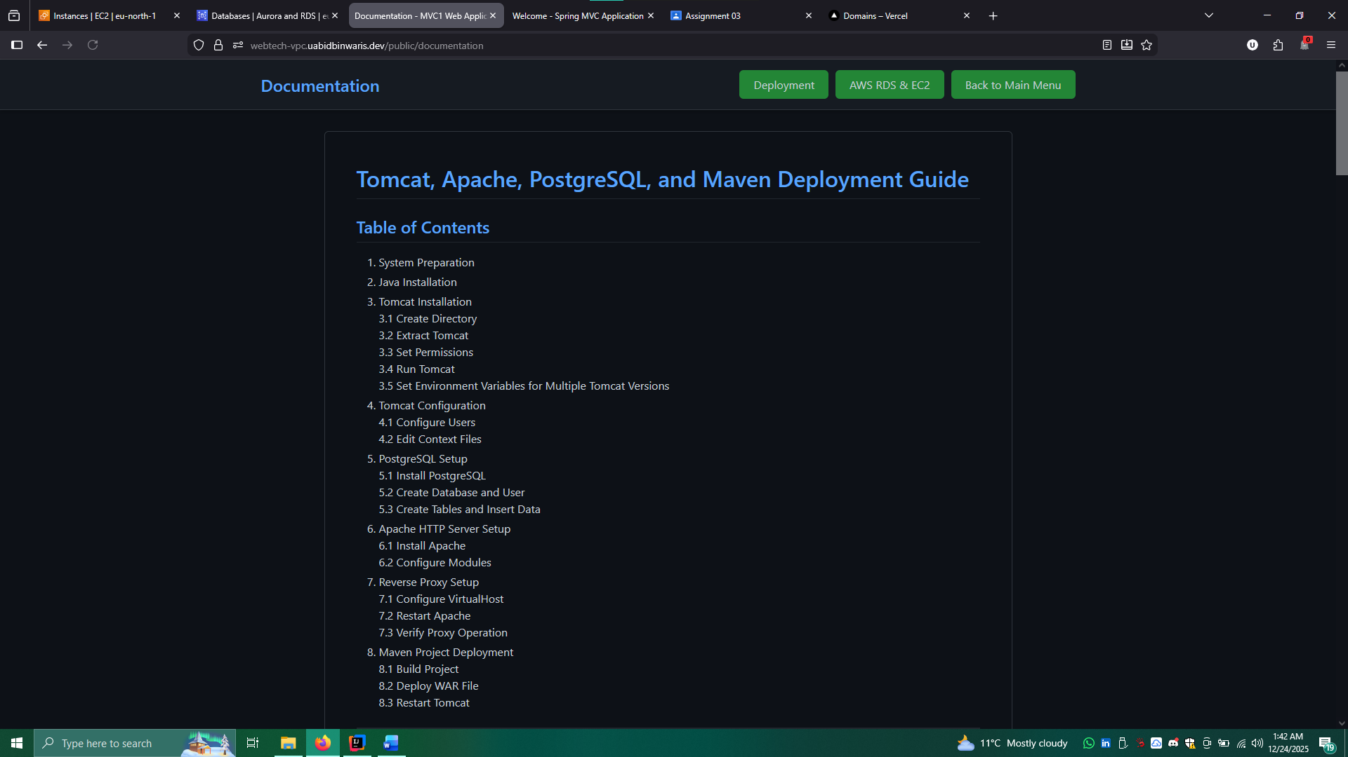

**Cost and Usage AWS**

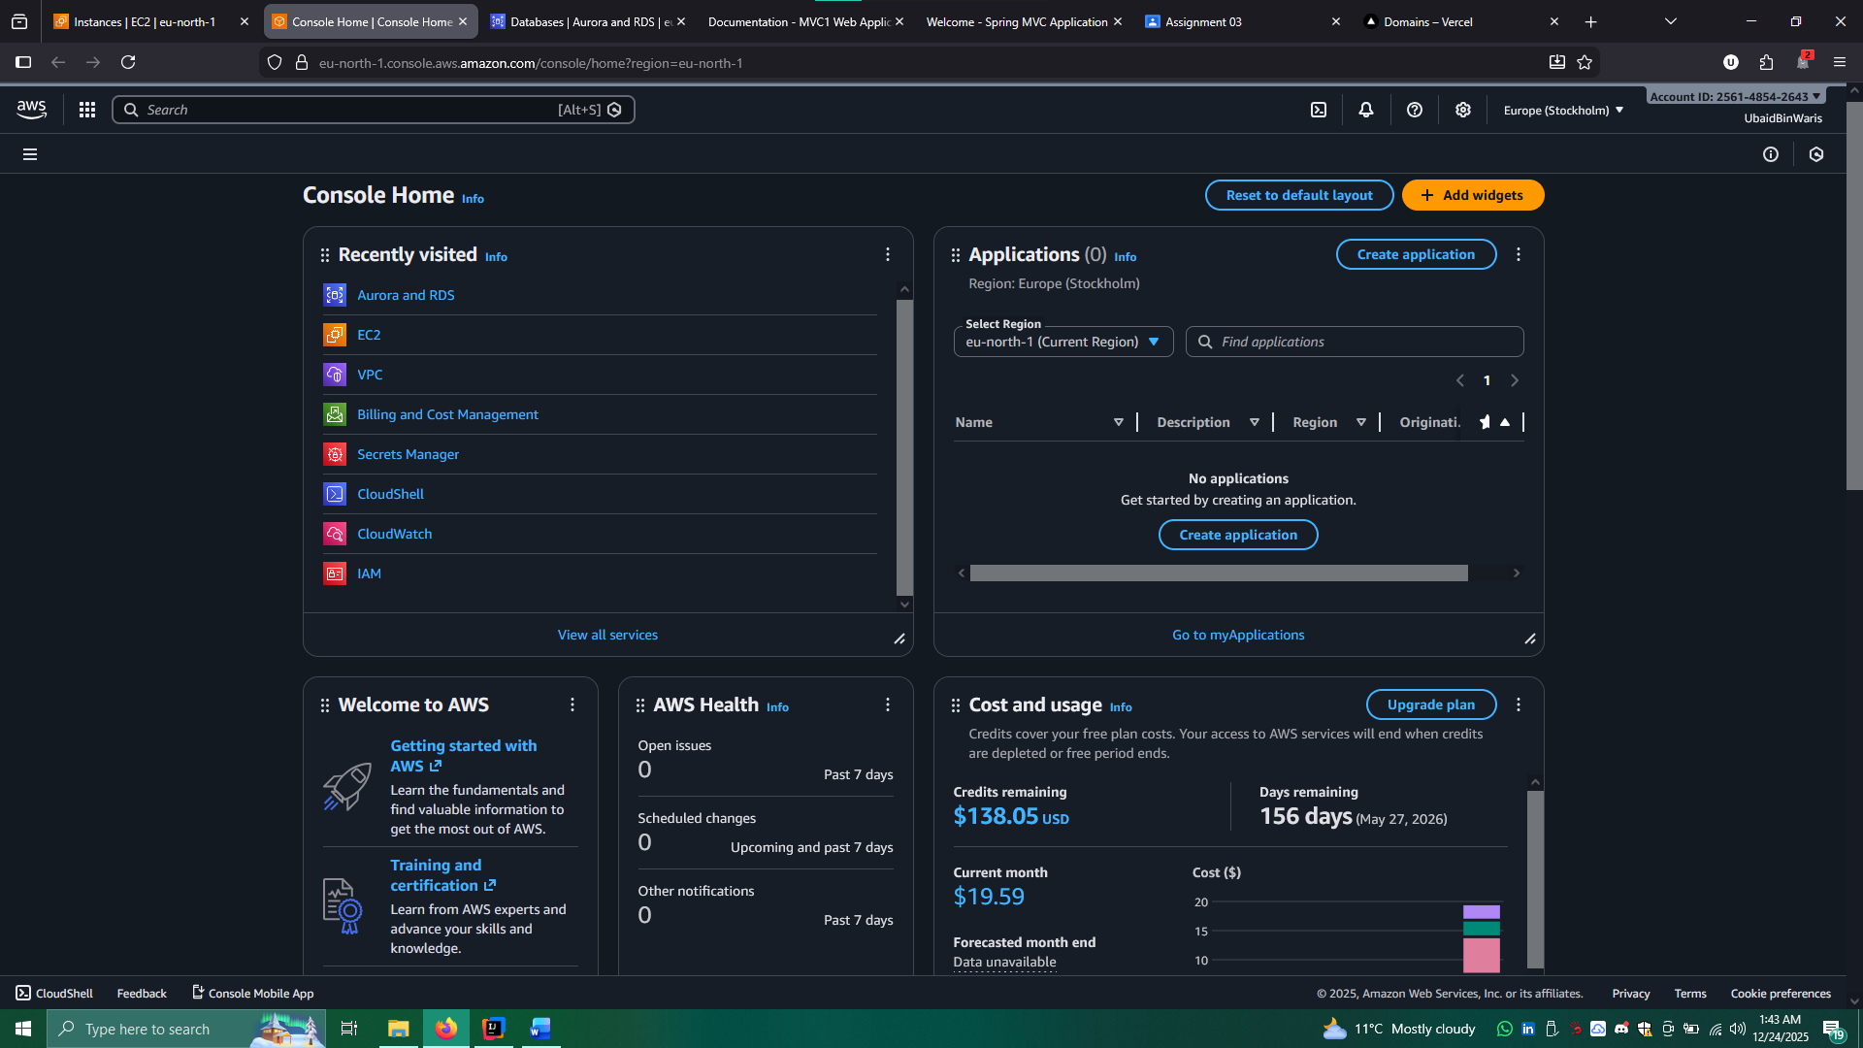

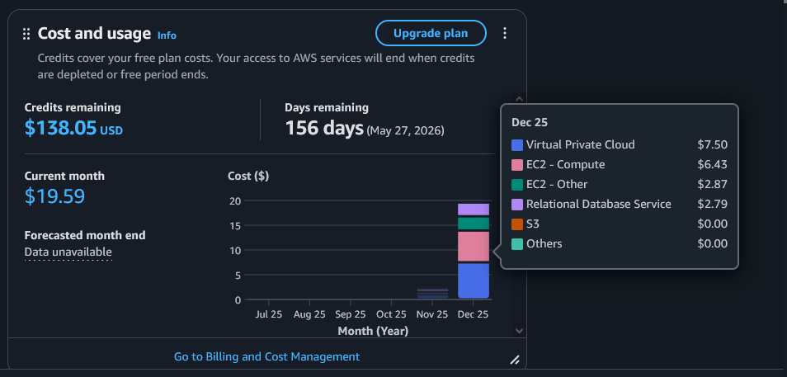

**VPC Setup**

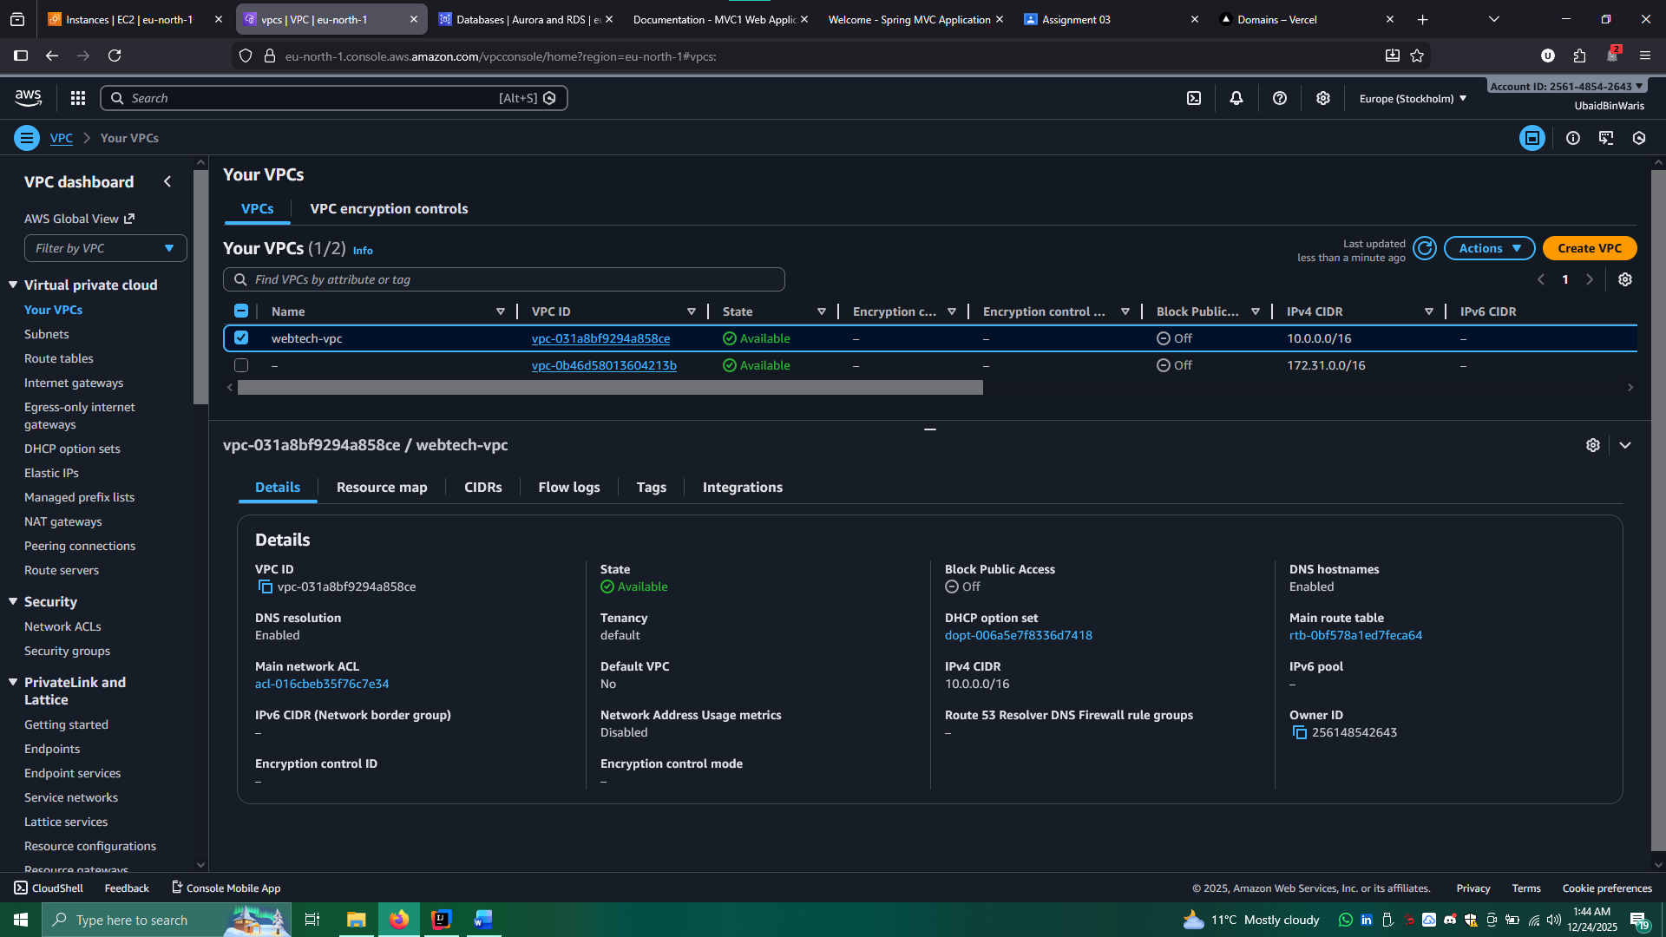

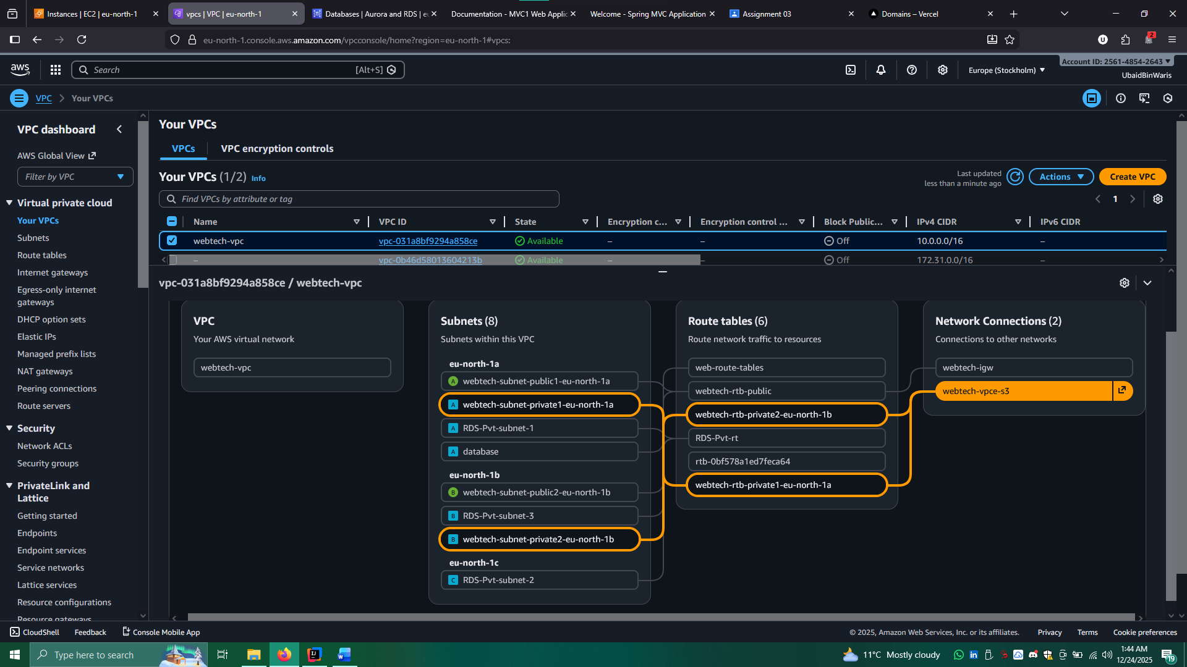

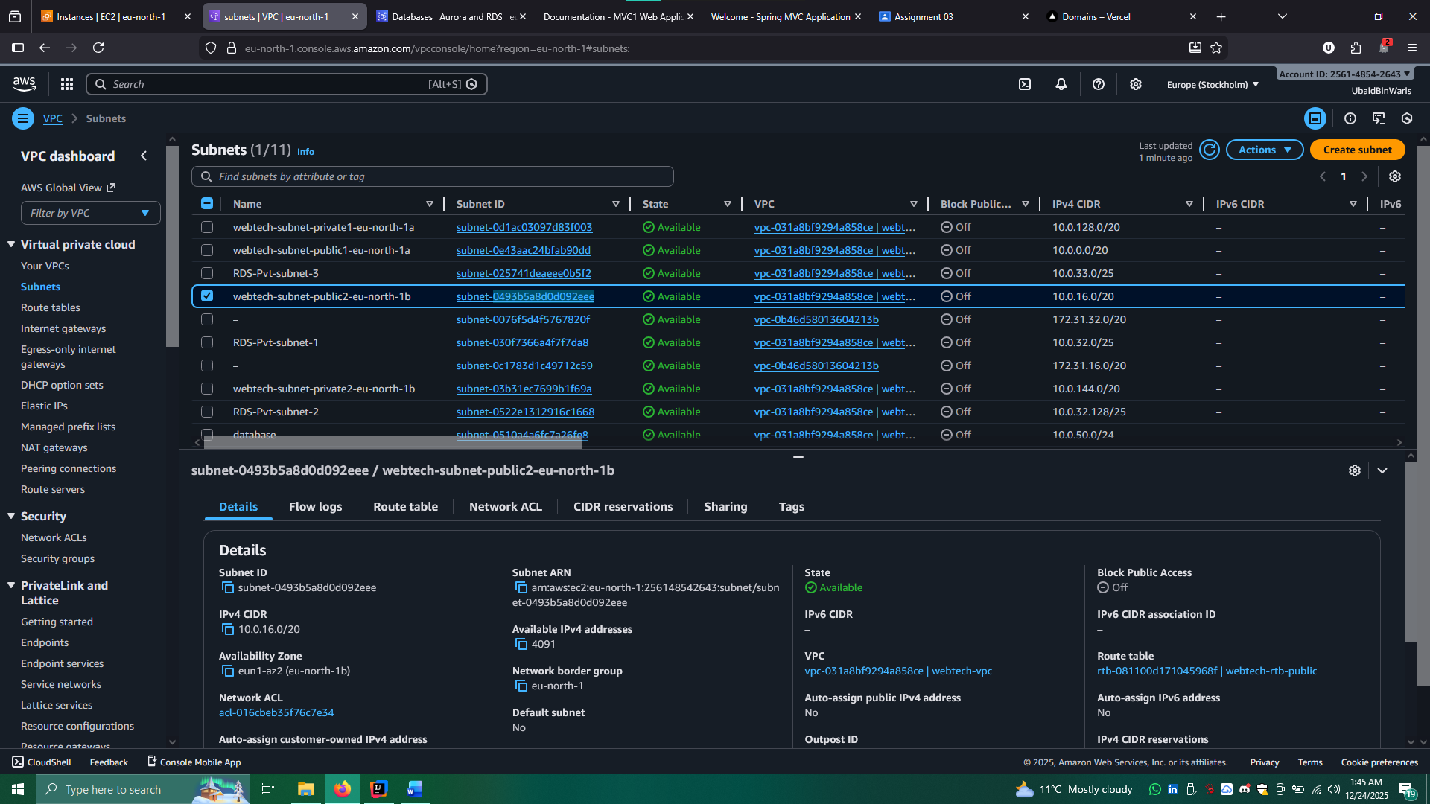

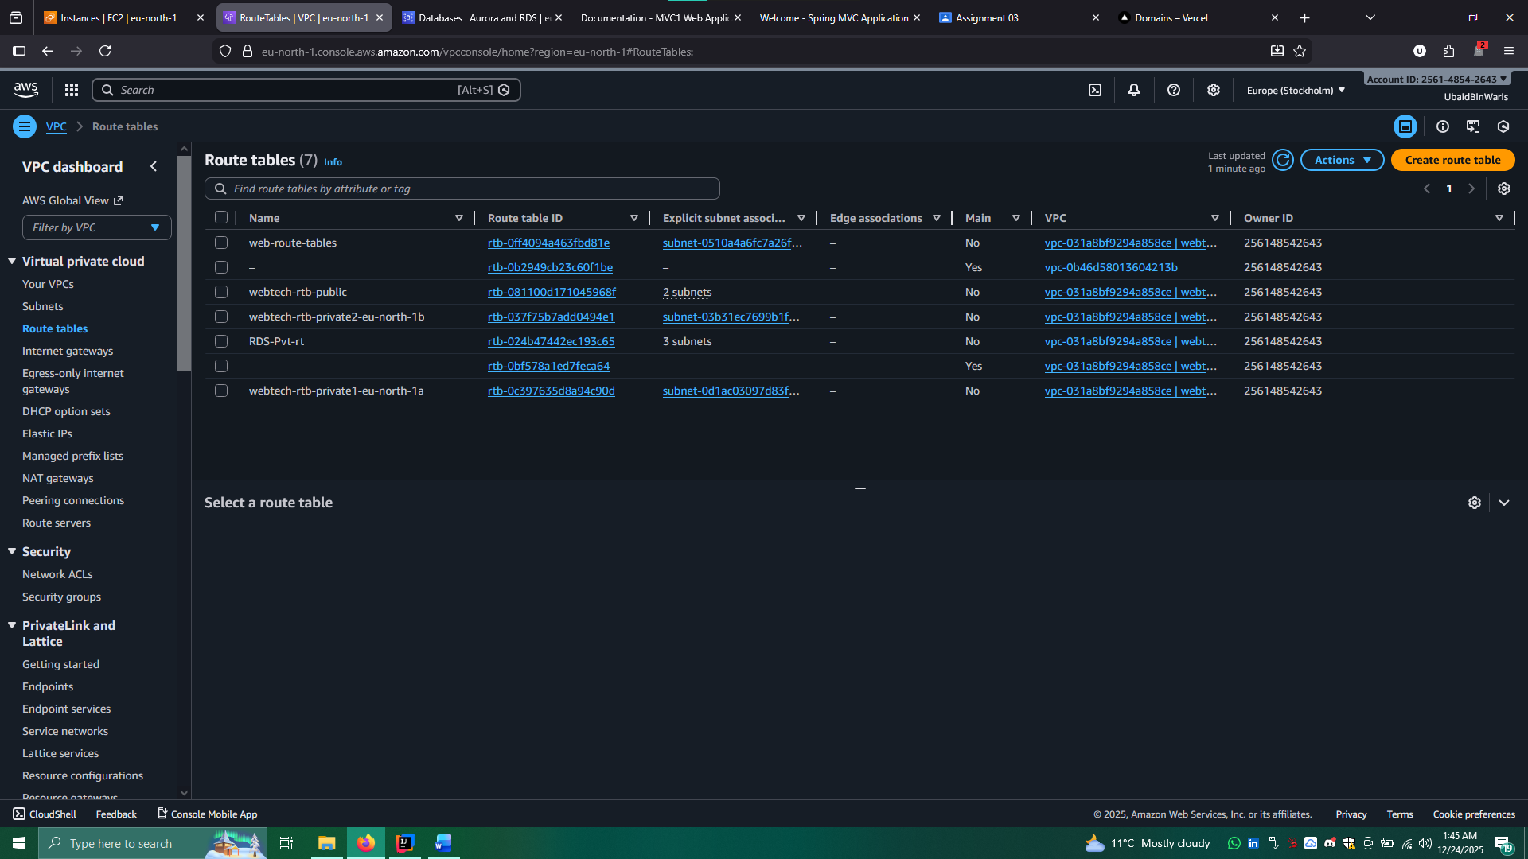

**EC2 Instance**

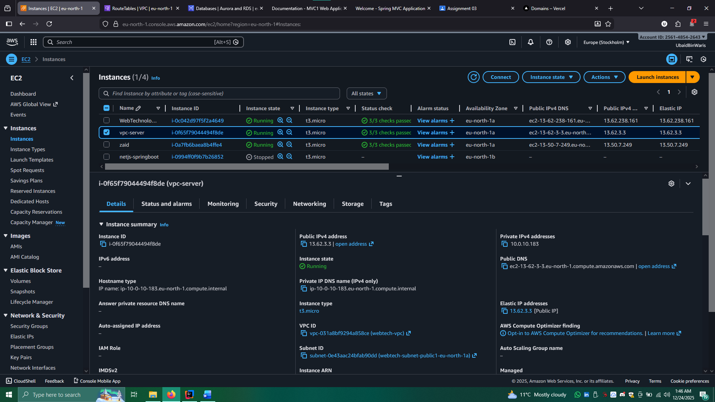

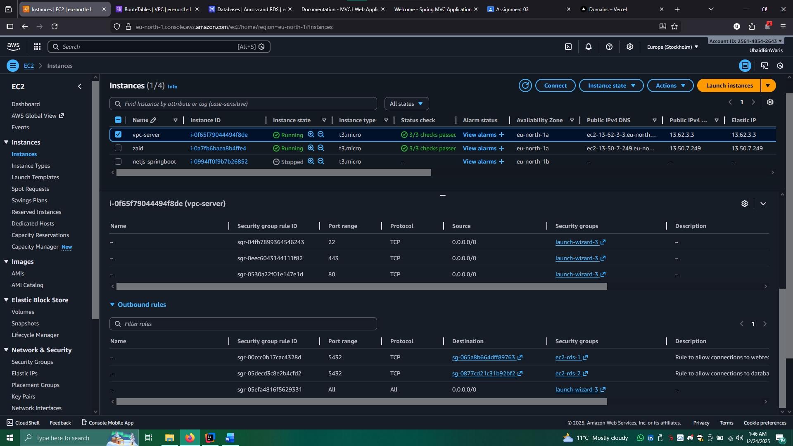

**RDS**

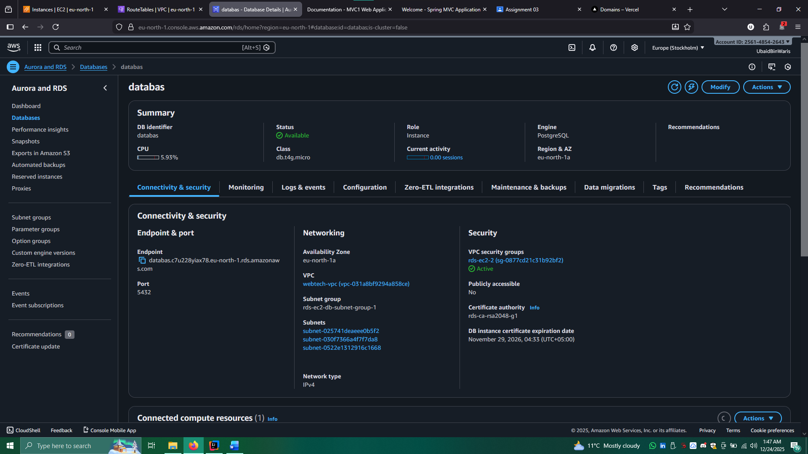

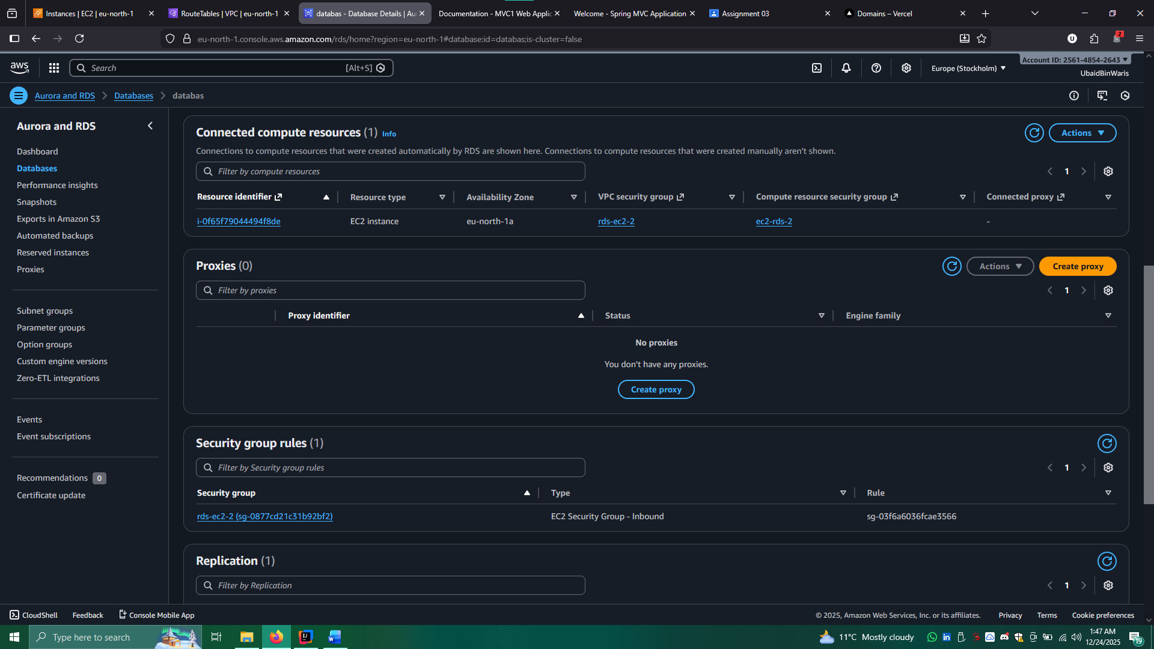

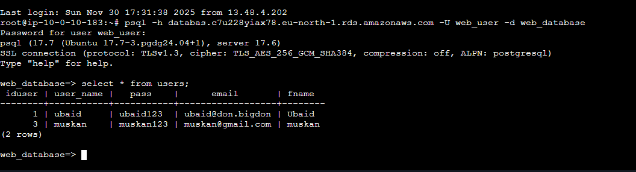

## Domain pointing

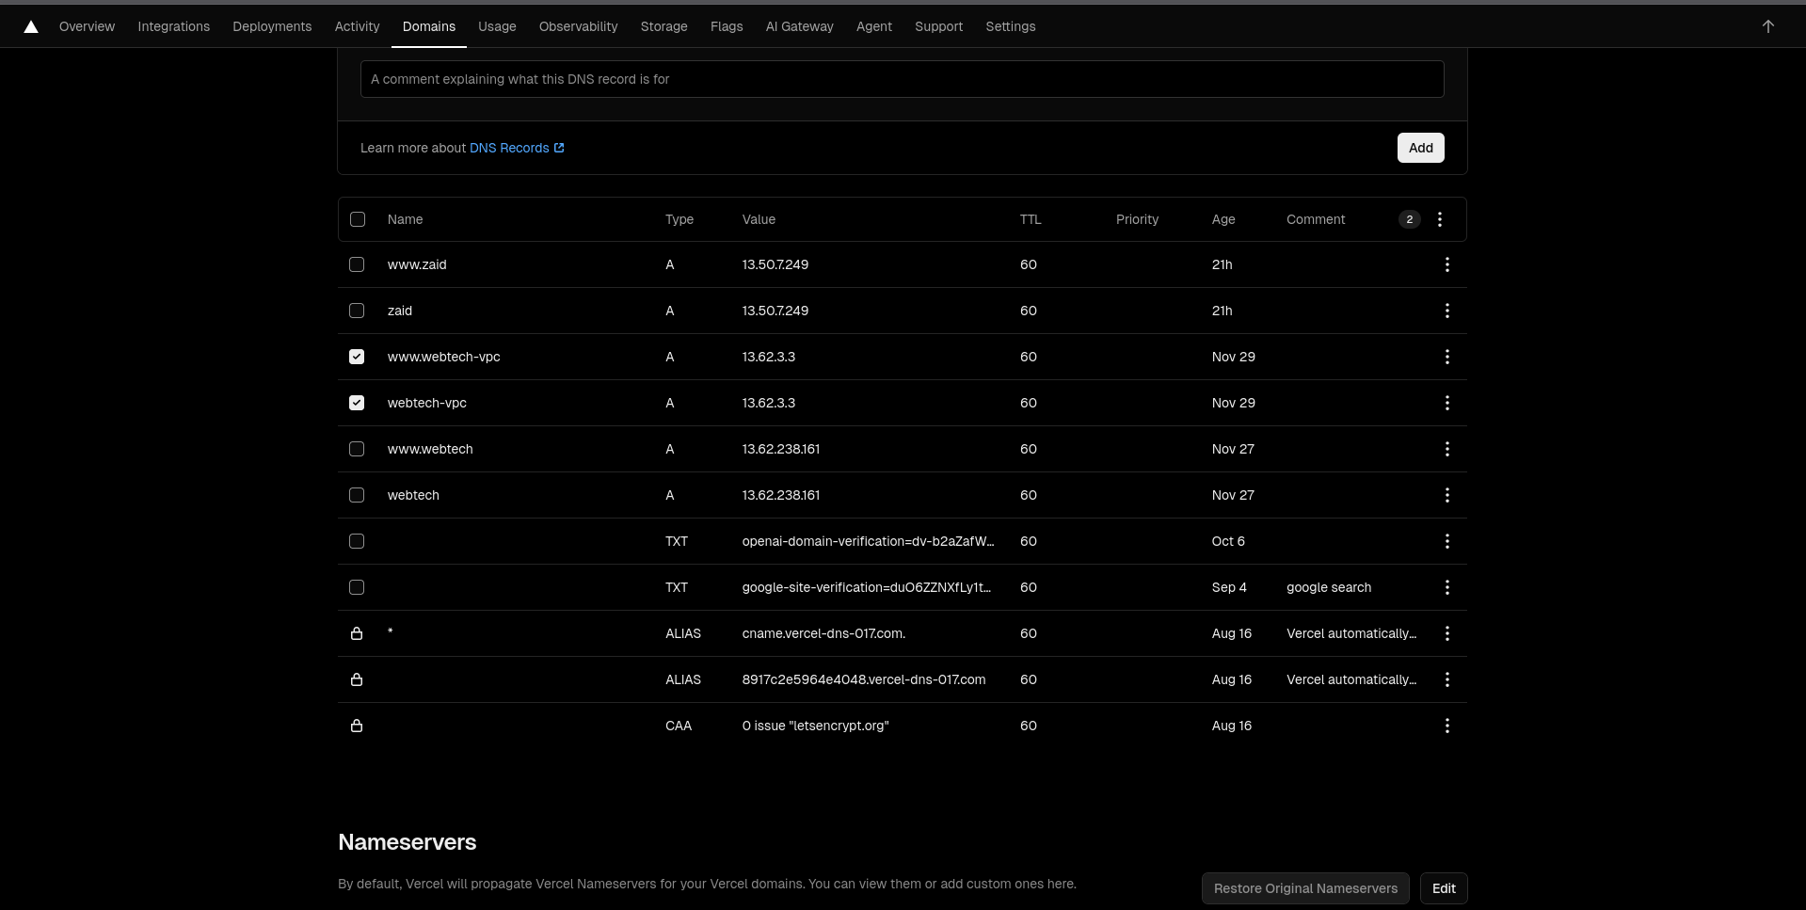

**SSL Certificate Installation (Certbot)**

Install Certbot and generate your SSL certificate:

sudo apt install certbot python3-certbot-apache -y

sudo certbot --apache -d webtech.uabidbinwaris.dev -d www.webtech.uabidbinwaris.dev

After SSL is successfully issued, verify the HTTPS setup:

curl -I https://webtech.uabidbinwaris.dev

curl -I <https://www.webtech.uabidbinwaris.dev>

Ensure EC2 security group allows inbound HTTP(80), HTTPS(443), and SSH(22).

**Reverse Proxy Setup**

SSL Certificate Installation (Certbot)

Install Certbot and configure SSL:

sudo apt install certbot python3-certbot-apache -y

sudo certbot --apache -d webtech.uabidbinwaris.dev -d www.webtech.uabidbinwaris.dev

## Acunetix web Scan

